Placing a Map below a Search Form and above results
Templates - Map and Minima
Plugins - SEBLOD Form & List Pack (2 plug-ins) - 20Euros, Address to Coordinates (free)

In this example we will be adding a field to the search form that calls the map template using Seblod Form and List Pack. We also use a template variation to call all the search form fields and the map.
Step 1
First create your content type as normal – in my case I created a content type called ‘Home Care’ which provides a list of care homes in the UK.
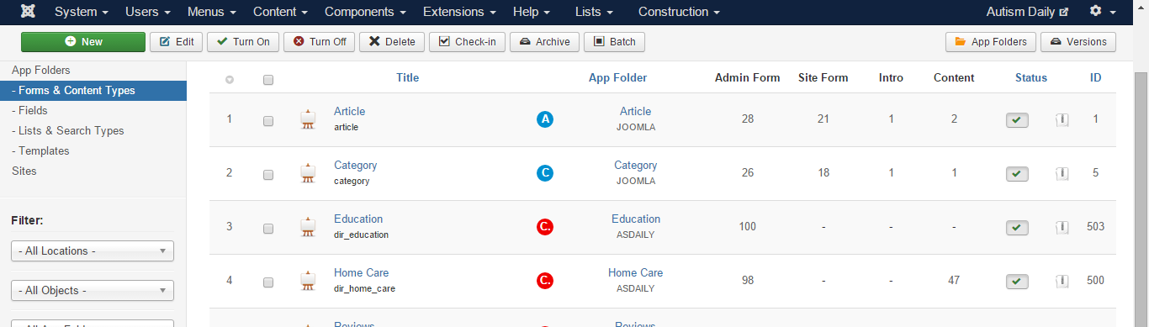
Step 2
Create two lists and search types for your content type – One for the normal search the other for the map view
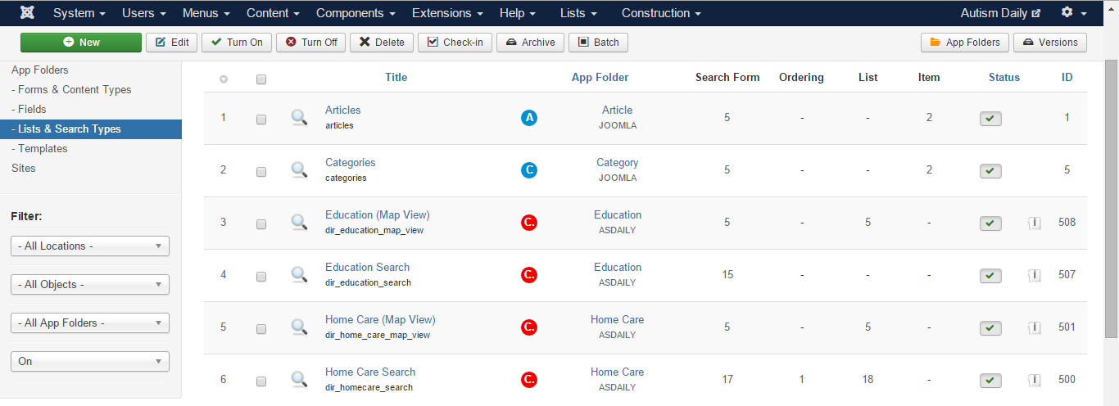

Normal search - Although you can use Seb-one Template I changed mine to Minima. Add your Search Fields – Address to Coordinates, Radius and Latitude and Longitude – set the Match – Watch Seblod tutorial on setting up search by radius if you don’t know how to do this.
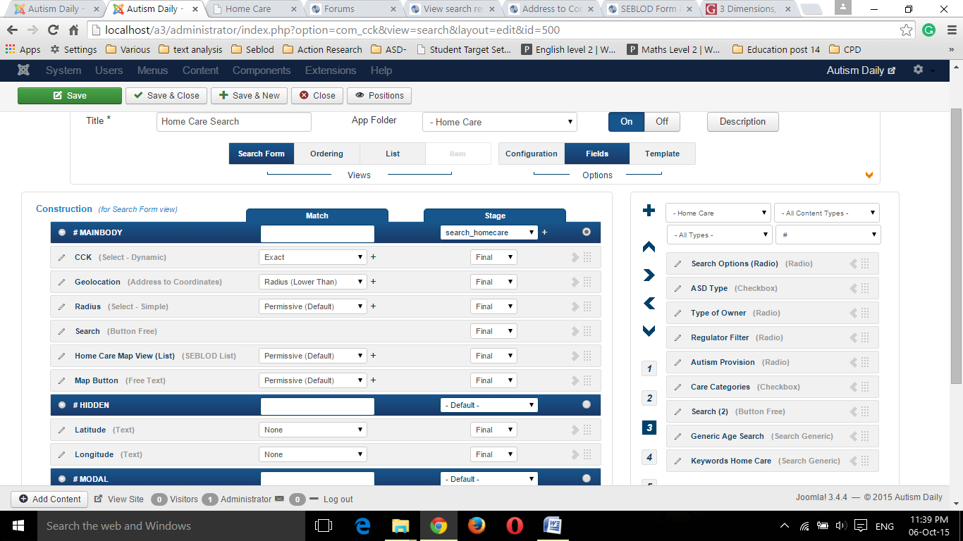
Create a template variation either in seb-one folder or minima depending which one you are using.

- Create a folder inside variations folder example – search_homecare
- Create a php file with the same name as the above folder – search_homecare.php
- Change the variation from default to your new template variation.
Your php file should look like this –I have added a style sheet and a new field at the bottom for the map – ‘home_care_map_view_list’
Step 3 – setting up your map using SEBLOD Form & List Pack (2 plug-ins). (green circles)
Create a list and search type for your content type using the map template (my example: Home Care (Map View)
Add the same Address to Coordinates, Lat/Long and radius fields that you added to your first search form and set the same match
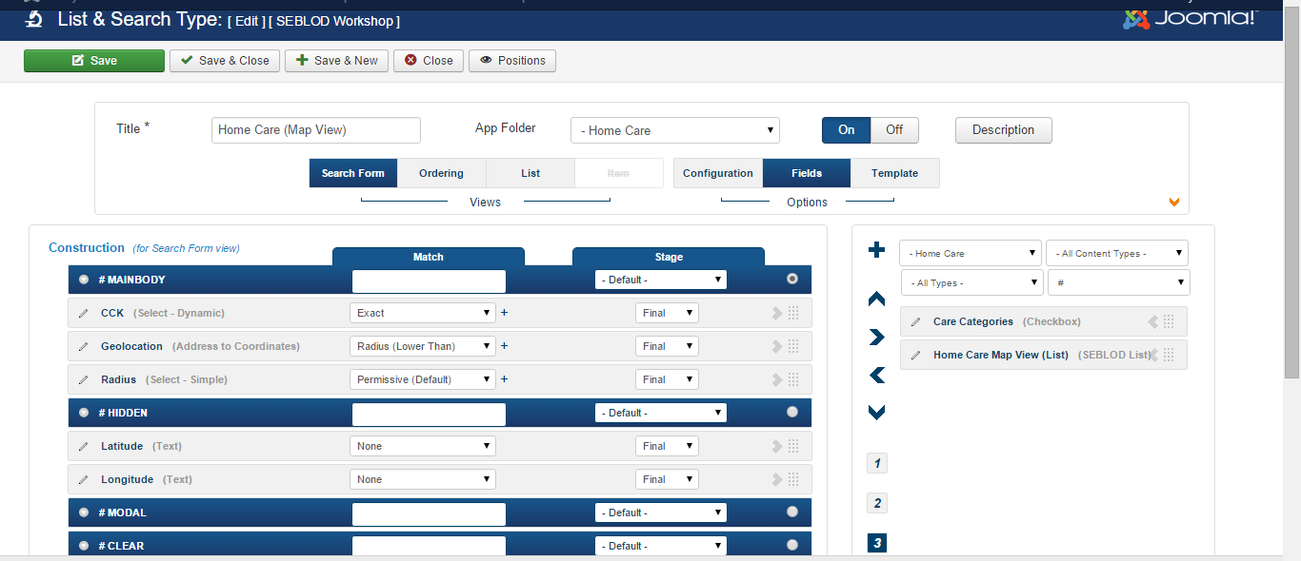
In configuration tab, at the bottom, set No Result Message style to none
In the list tab (I’m using template Map mode = coordinates) add your lat/long fields and whatever fields you want to appear in the info window.
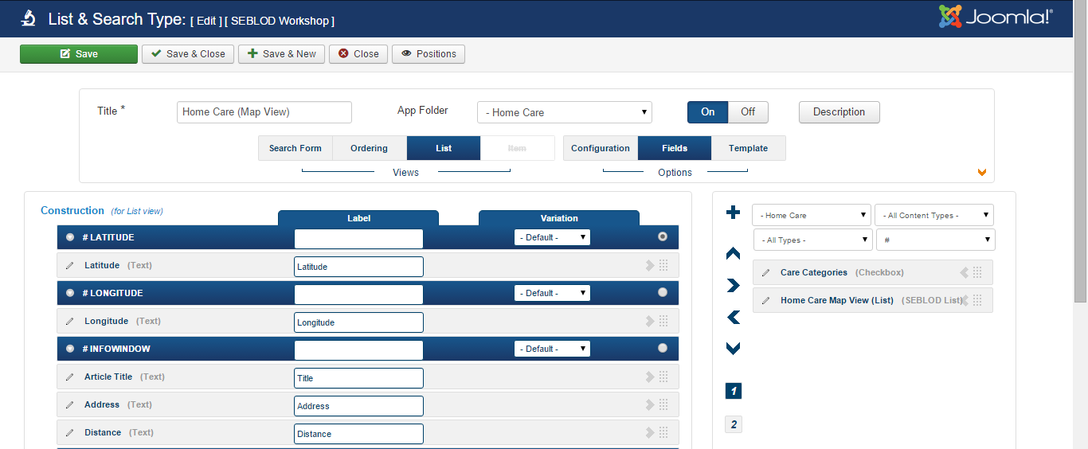

Now go back to your first search form and create a field using SEBLOD Form & List Pack (2 plug-ins).
In my example = home Care Map View (List)

Which looks like below. In the list and search type, type in the name of your map search created in step 3. Storage none
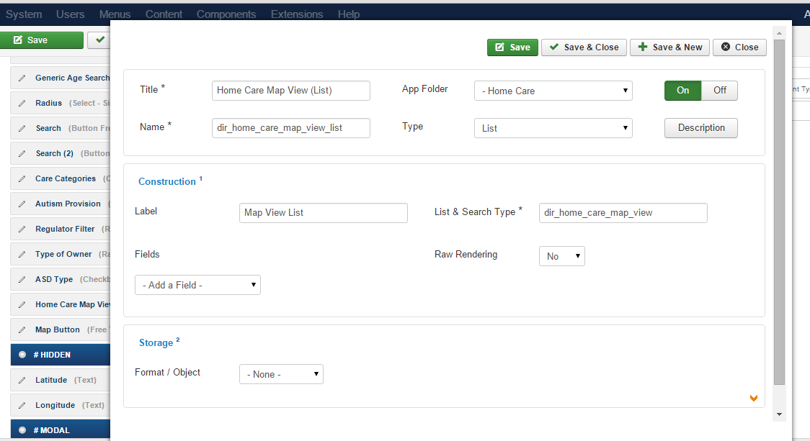

I’ve put this tutorial together quite quickly as a brief guide and I hope it makes sense. In some fields you see them named with dir_ at the beginning (ignore this dir_ as it is my unique name for the fields which may not be correct) Make sure your fields are correctly named.

