How to show a User profile ( or Allow User to see and modify his profile)

You have 2 ways :
- Using Joomla User management
- Using Lists with Seblod.

This tutoriel is only about the 1rst case : using Joomla User management.

Before, doing anything, you need to check if the bridge between both systems is activated:
> Extensions > Plugin Management
Filter :
Cck_storage_location

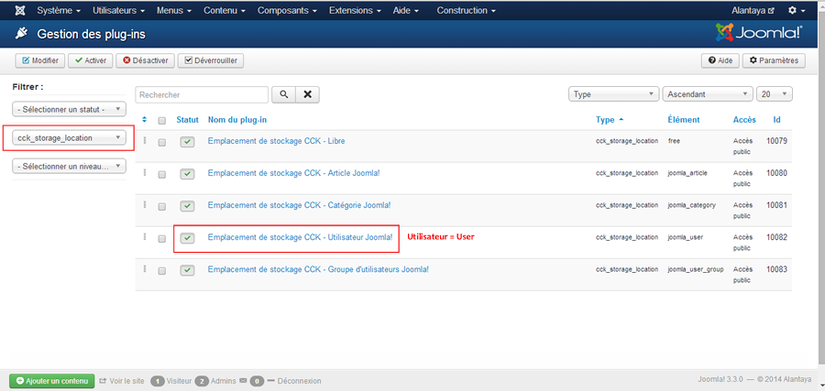

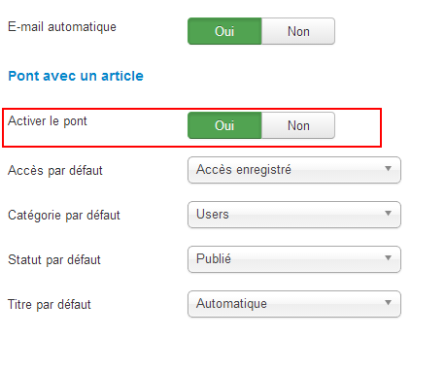
Just clic sur « activate ».

Then, add a « Profile User » to your menu by using the usual link.

