Getting started with jSeblod CCK: brief hands-on tutorial on template use

Part 1: Overview
In the previous tutorial, we introduced the concept of Fields and Content Types and how these can be leveraged in creating robust content entry and presentation in Joomla through jSeblod CCK. In this next tutorial, we look at how to create content for a simple music sharing site and how to create a template to display the results. It will be a good refresher and further example of how to use Fields and Content Types. If you have not read the previous tutorial, we suggest you do so before delving in so that you are not over your head in the admittedly complex but powerful jSeblod CCK. First we present the ideas behind the tutorial, and then we give you step-by-step instructions on how to actually create the items.

Music to my ears
With this tutorial, you will create a music-based website. The basic idea is to allow users to upload an mp3 file. Of course, that alone would be too boring, so we’ll allow users to also upload an image and add information about the song like title, artist, etc. To do this, you’ll need to use a template. But what, exactly, is a template? jSeblod CCK leverages Joomla’s native template system, and in essence, when you create a template, you are creating something like a template you might download to change the look of your Joomla website. The jSeblod templates are not intended to change the look of your site, however, they just change the look of how your content is gathered and displayed from users. jSeblod CCK has templates for the frontend and the backend, and for users and administrators. Using templates, you can change the way your page looks when a user submits information to you. You can change the way your page looks when users view the data they have submitted. You can even have multiple different views for the same data, for example, a brief page that only shows 10 pieces of information and a full page that shows everything. The real power of templates lies in the fact that they use HTML and PHP.

A template, a template, what is in a template?
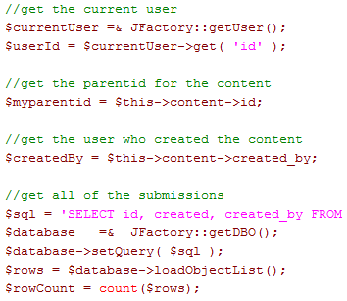
The HTML in a template is the same HTML that is used to create basic web pages. Each template also has CSS styling, so you can control every aspect of how your data is displayed. Knowing CSS is integral to understanding HTML these days. If you don’t understand HTML or CSS, then this tutorial is likely to confuse you; I recommend doing a few HTML and CSS tutorials and then coming back later (plenty of great basic HTML and CSS tutorials are free. PHP is a web programming language. It is what most sites run on. It is Joomla’s code. The cool thing about using PHP in templates is that you can do just about anything you can think of that Joomla can do within your pages. PHP and HTML/CSS are all mixed together in the template, and the result is something pretty and functional for your site’s visitors.

But, how exactly do I make and enable a template?
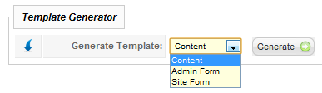
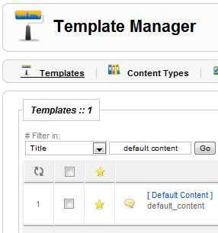
Lucky for you, jSeblod CCK will generate a template for you. This auto-generated template will give you a starting place to work. jSeblod CCK comes with a bundled template, and these are actually in use from the moment you create a Content Type. Have you noticed the “[Default Content]” and “[Default Form]” fields under the “Tempates” area in your Content Types? These are sophisticated templates that are written to display all of the fields in your content (the code in them figures out what fields you have selected for display and generates the appropriate HTML). So, if you use jSeblod CCK, you are already using templates that come with the package – you just didn’t know it. You can create your own templates using a number of methods, but the easiest way is to use the “Generate Template” feature from the “Content Type Manager” page on the backend. jSeblod supplies some basic methods for creating the HTML elements you’ll need for templating. You can make modifications to the generated templates or go further and make your own from scratch. We’ll go into the details below.

I see three template types, what are they?
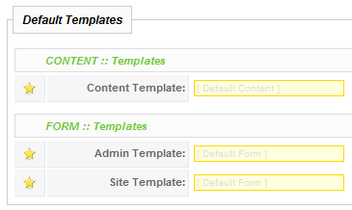
When you make a new Content Type, you’ll see three templates under the “Default Templates” group: Content Template, Admin Template, and Site Template. A Content Template is the displays content on the site. It may more appropriately be called a “Static Display Template”. The “Form” templates are submission/editing forms. An Admin Template allows entry or editing of data on the backend while a Site Template allows entry or editing of data on the frontend.

What other types of templates can I make?
In Joomla, the “category” or “blog” views are used to make lists of articles. Similarly, jSeblod allows custom “category” type views that are defined using special templates. These basically display information based on multiple content items and can be used to put them into a nice summary view. In our example, this type of view could be used to make a simple alphabetical list of all songs or to create a “blog” type view with song title, song picture, and album information in a two or three column, nicely formatted view.

Part 2: Step-by-step tutorial
In part two, we’ll show you how to actually make a simple music sharing site. If you haven’t read Part 1 yet, take a moment to read it for a nice overview.

Step1: Create Your Fields
- Create the Field for users to enter in a song title.
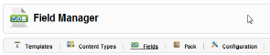
  - Open the “Field Manager” from either the main Joomla administrator page or the jSeblod CCK Control Panel.
  - Click “New” to add a new Field.
  - Select Field Types>Form>Input>Text on the left.
  - Fill in the details
    - Title: This is the “human friendly” name of the Field. Enter “Song Title”
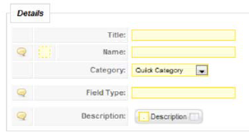
    - Name: This is the “machine friendly” name of the Field (it can’t contain spaces). Enter “song_title”.
    - Category: This is the “Field Category”, which is just an easy way to group fields together later (since there may be a lot). You can add your own Field Categories. For now, select “Quick Category”.
    - Label: This will be the text label next to the field when it appears on a form. If you leave it blank, the Title you entered above will be used. Enter “Title”
    - Required: Select “Yes”.
  - Click “Save”
- Repeat the above for the following text Fields:
  - Artist
  - Album
- Create the Field for users to upload an image.
  - Open the “Field Manager” from either the main Joomla administrator page or the jSeblod CCK Control Panel.
  - Click “New” to add a new Field.
  - Select Field Types>Files/Folders>Upload>Image on the left.
  - Title: Enter “Song Image”
  - Name: Enter “song_image”
  - Category: Select “Quick Category”.
  - Folder: This is the path to where the image will go. Enter “images/stories” (or wherever is appropriate for your Joomla install).
  - 1 Folder/User: Select “Yes”. This will create a folder for the current user.
  - 1 Folder/Content: Select “Yes”. This will create a folder for the current content.
  - Click “Save”
- Create the Field for users to upload a song file.
  - Open the “Field Manager” from either the main Joomla administrator page or the jSeblod CCK Control Panel.
  - Click “New” to add a new Field.
  - Select Field Types>Files/Folders>Upload>Simple on the left.
  - Title: Enter “Song File”
  - Name: Enter “song_file”
  - Category: Select “Quick Category”.
  - Folder: This is the path to where the music file will go. Enter “images/stories” (or wherever is appropriate for your Joomla install).
  - Legal Extensions: enter “mp3”.
  - 1 Folder/User: Select “Yes”. This will create a folder for the current user.
  - 1 Folder/Content: Select “Yes”. This will create a folder for the current content.
  - Click “Save”
- Create the Form Action Field. This field is key in determining who can submit and view your music content.
  - Open the “Field Manager” from either the main Joomla administrator page or the jSeblod CCK Control Panel.
  - Click “New” to add a new Field.
  - Select Field Types>Form>Action on the left.
  - Title: Enter “Song Action”
  - Name: Enter “song_action”
  - Category: Select “Quick Category”.
  - Action Mode: Select “Article”.
  - Publication: Select “Yes”. This means the default value for Published in Joomla is set to “Yes”.
  - Access Level: Select “Registered”. This is who can view the content that is submitted.
  - Category/Parent: Select an appropriate Category for your Joomla installation. If you don’t understand categories, there are a lot of Joomla tutorials to help you out.
  - Leave the “Max in…” fields at their default. These can be changed if you want to limit the number of submissions.
  - Default Author: Select “Administrator” or whoever you’d like. This doesn’t apply to our setup as we require users to be logged in to submit, but if you allow anonymous users to submit, this Default Author is the Author that will be recorded in the database.
  - Creation Access: Select “Author”. This will decide who can access the submission form.
  - Message: Enter something like “Thank you for submitting the song to us!” This field determines what text will be shown once the user successfully submits a song.
  - Redirection: Select “Content”. This field determines where the user will be redirected after submission. Content will show them what they just submitted. You can use the other options for more customized redirection depending on your specific needs.
  - Click “Save”

Step 2: Create a new “Song” Content Type
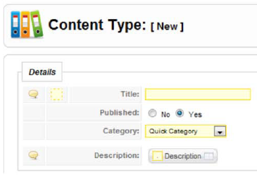
- Open the “Content Type Manager” from either the main Joomla administrator page or the jSeblod CCK Control Panel.
- Click “New” to add a new Content Type.
- Fill in the Details
  - Title: “Song”
  - Published: “Yes”
  - Category: “Quick Category”
- Leave the “Default Templates” and “Admin Form Views” alone for the moment.
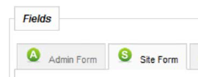
- Add Fields to the Forms using the controls on the right. First, well add Fields to the Site Form.
  - Click on the “Site Form” tab.
  - Add your custom Fields
    - Filter to your custom Fields by selecting “Quick Category” from “All Field Categories –“ below the “Available” column heading,
    - Add your custom fields by double clicking them.
  - Now, add some fields to help with data entry
    - Filter to form related Fields by selecting “Form” from “All Field Categories –“ below the “Available” column heading,
    - Add the following Fields by double clicking:
      - Button Reset
      - Button Submit
  - Next, you’ll need to change the “Form Action” type to the “Song Action” created above.
    - Using the pull down menu, change “Default Action” to “Song Action”.
- Next, add Fields to the Admin Form.
  - First, highlight all of the Fields you just added to the “Site Form” tab.
  - Next, click the “-> Admin” button. This will copy all of the Fields to the “Admin Form” tab.
  - Click on the “Admin Form” tab and confirm that the Fields are all copied.
- Finally, whatever you include in the Site Form is what will show up by default in the Content field.
  - Click on the Content tab and verify that all the fields are displayed. Don’t worry, even though we don’t need buttons to display in the static content views, it doesn’t matter because jSeblod automatically removes the buttons in the content view.
- Click “Save”

Step 3: Create a Content Template for the “regular” content view: index.php
- Open the “Content Type Manager” from either the main Joomla administrator page or the jSeblod CCK Control Panel.
- Generate a template .zip file from your “Song” Content Type
  - Click on the check box next to the “Song” Content Type.
  - At the bottom of the page under “Template Generator”, select “Content”, and click the “Generate” button.
  - Save the resulting Zip file to your hard drive and unzip it.
  - Unzip the file to a directory on your computer and open up the directory.
- Create the customized category view file for the template, the “index2.php” file.
  - Make a copy of the file “index.php”.
  - Rename the copy “index2.php”.
- Change the templateDetails.xml file to include the custom files you are about to create and modify.
  - Open the “templateDetails.xml” file in a text editor.
  - Enter in two <filename> XML elements by inserting the following text just before the “</Files>” line (don’t enter the quotation marks):
    - “<filename> index2.php </ filename>”
    - “<filename> css / style.css </ filename>”
  - Save the file.
- Change the index.php file to accommodate our CSS file and make a nice layout for our song item.
  - Add lines so that index.php recognizes our CSS file.
    - Find the lines:
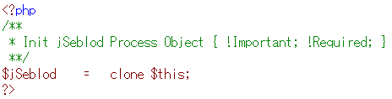
    - Copy and paste the following code after it:
<?php
// Add CSS
$document =& JFactory::getDocument();
$document->addStyleSheet( $this->baseurl.'/templates/'.$this->template.'/css/style.css' );
?>
  - Understand how to reference saved information using PHP and jSeblod
    - To reference an uploaded image, we can use PHP and an interface provided by jSeblod that follows the format “$jSeblod->FIELD_NAME->thumb1”
    - To reference a field value, we can use PHP and an interface provided by jSeblod that follows the format “$jSeblod->FIELD_NAME->value”
    - To reference a label, we can likewise use jSeblod with the format “$jSeblod->FIELD_NAME->label”
  - Add the necessary PHP code to the index.php file.
    - Copy and paste the following code at the very end of the index.php file:
//Add our custom HTML using PHP to access stored values
<img src="<?php echo $jSeblod->song_image->thumb1; ?>" alt="<?php echo $this->content->title?>" class="song_image" />
<h3><?php echo $jSeblod->m_info4->label; ?> - <?php echo $this->content->title?></h3>
<p><?php echo $jSeblod->song_artist->label; ?> : <?php echo $jSeblod-> song_artist ->value; ?></p>
<p><?php echo $jSeblod->song_album->label; ?> : <?php echo $jSeblod->song_album->value; ?></p>
<div class="clr"></div>
<div class="song_play">{play}<?php echo $jSeblod->song_file->value; ?>{/play}</div>
    - The “song_play” class with the {play}{/play} tags will allow us to use the Joomla “JosDewPlayer” audio player plugin to play the files.
  - Save your index.php file.
- Add nice formating to the style.css file so our data looks awesome.
  - Open the style.css file and copy and paste the following text:
.song_image{
background-color: #FFFFFF;
padding: 4px;
border: solid 1px #CCCCCC;
float: left;
margin: 0 10px 10px 5px;
}
.clr{
clear: both;
}
.song_play{
margin: 10px auto;
width: 200px;
}
  - Save your .css file.

Step 4: Create a Content Template for the brief “category” content view: index2.php
- Open the file index2.php in your text editor.
- Copy the text from index.php into index2.php to use as a starting point.
- Remove the fields that you do NOT want to show in the brief view.
  - Remove the line with “song_album” so album will not show up.
  - Remove the line with “song_file” so the playable song file will not show up.
- Save index2.php

Step 5: Install your newly created template <<need to finish>>
- <<how to install here>>
- <<Use the name “song_template”>>

Step 6: Need your template in multiple languages?
- Create a language file for your template
  - Using your favorite text editor, create a file name using the Joomla language prefix (e.g. fr-FR for French) and the name of your template, “song_template” and finally “.ini”, for example “fr-Fr.song_template.ini”
  - Save this in the Joomla language directory under language/ and then the language type (e.g. fr-Fr).
  - Create an entry for each phrase you need to translate in your template. For example, if you want to translate the label for “Album” you might add a line like this: “ALBUM TITLE= Titre de L'album
  - Open up your template file, and replace any references to the text with a JTEXT variable.
// old text: <p><?php echo $jSeblod->song_album->label; ?> : <?php echo $jSeblod->song_album->value; ?></p>
<p><?php echo JText::_(‘ALBUM TITLE’); ?> : <?php echo $jSeblod->song_album->value; ?></p>
  - Repeat for each of the fields and each of the languages you need translated.

Part 3: Summary
You should now have an solid, basic understanding of templates. Templates are a mixture of HTML, CSS, and PHP. They control how you gather and display data from your users. They are as powerful as Joomla itself because they are actually native Joomla templates. In them, you can use PHP functions that are provided by jSeblod CCK and any of the Joomla PHP functions, or you can make your own from scratch.
Good luck! If you need help, join our active discussion boards for advice from developers and other jSeblod users.
This tutorial was created by a jSeblod novice who was extremely impressed with the power of jSeblod. It was adapted from the existing introductory tutorial by Slotpro.

